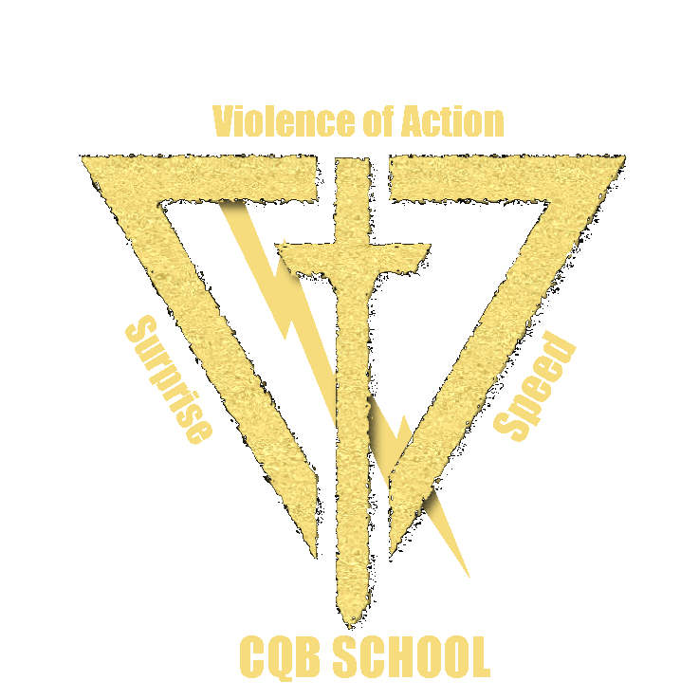
ELMORE COUNTY SHERIFF’S OFFICE

“LONE WOLF” ONE MAN CQB COURSE CURRICULUM

STUDENTS WILL BE TAUGHT THE FOLLOWING:

- PROPER OPERATOR MINDSET
- PRINCIPLES OF ONE MAN CQB
- ONE MAN ROOM CLEARING WITH A PISTOL
- PROPER FOOTWORK
- PROPER APPROACH TO DOORWAY
- PROPER APPROACH TO ENTERING THE ROOM
- USING OBJECTS AS CONCEALMENT
- KNOWING WHEN TO MOVE FAST AND WHEN TO MOVE SLOW
- IDENTIFYING IMMEDIATE DANGER AREAS
- THE IMPORTANCE OF SURPRISE
- THE IMPORTANCE OF BEING COVERT
- UNDERSTANDING HOW FAST TO MOVE BASED ON SHOOTING ABILITY
- HOW TO USE A CLEARED SPACE TO YOUR ADVANTAGE
- HOW TO PROPERLY OPEN CLOSED DOORS
- ONE MAN ROOM CLEARING WITH A RIFLE
- PROPER FOOTWORK WITH A RIFLE
- PROPER APPROACH TO DOORWAY WITH A RIFLE
- PROPER APPROACH TO ENTERING THE ROOM WITH A RIFLE
- HOW TO PROPERLY OPEN CLOSED DOORS WITH A RIFLE
- PISTOL FUNDAMENTALS (RED DOT ZEROS)
- ACQUIRING RED DOTS ON PISTOLS
- DRAW AND FIRE PISTOL DRILLS
- PROPER PISTOL MAGAZINE CHANGE DRILLS
- RIFLE FUNDAMENTALS (RED DOT ZEROS AND HOLD OFFS)
- FROM LOW READY TO TARGET SNAP DRILLS
- PROPER RIFLE MAGAZINE CHANGE DRILLS
- TRANSITION DRILLS FROM PISTOL TO RIFLE AND RIFLE TO PISTOL
- CORNER CHECKS IN KILL HOUSE WITH SIM ROUNDS PISTOL
- CORNER CHECKS IN KILL HOUSE LIVE FIRE PISTOL
- CLEARING FROM OUTSIDE THE ROOM WITH SIM ROUNDS PISTOL
- CLEARING FROM OUTSIDE THE ROOM LIVE FIRE PISTOL
- ONE MAN ROOM CLEARING LIVE FIRE KILL HOUSE PISTOL
- ADVANTAGES AND DISADVANTAGES OF USING A SHIELD
- CORNER CHECKS IN KILL HOUSE WITH SIM ROUNDS RIFLE
- CORNER CHECKS IN KILL HOUSE LIVE FIRE RIFLE
- CLEARING FROM OUTSIDE THE ROOM WITH SIM ROUNDS RIFLE
- CLEARING FROM OUTSIDE THE ROOM WITH LIVE FIRE RIFLE
- ONE MAN ROOM CLEARING LIVE FIRE KILL HOUSE RIFLE
- PROPER TAC MED TRAINING AND MED KIT SETUPS

**Please note this course is in NO way meant to discourage or replace ALERRT. Tactics shown during this course are not conducive to active shooter or direct threat scenarios. This course is for law enforcement officers who find themselves sometimes clearing rooms alone or at least until backup arrives. Additionally, this course is good for School Resource Officers who are tasked with clearing different size rooms by themselves inside of a school.
Cost: $275.00 per Person
This is a Gentlemen’s Course. Meals and lodging will not be provided.
Pistol Rounds: 500
Rifle Rounds: 500
Sim Rounds: 200

